**Group1 Project Report**

Project name: ${TaoKe}_{（淘客）}$

朱勋明 2030026229

熊一鸣 2030026170

胡行 2030026264

何贝儿 2030026047

黄媛骞2030026065

Link：<http://stuweb.uic.edu.cn/q030026047/DBMS/Login.php>

Our websites are to build an online shopping platform, which allows users to browse information of many kinds of goods and buy them on the Internet. The reasons are as follows: 1. It can help us better understand the operation of business, especially e-commerce, which is of great help to our future career choice. 2. It can enhance our abilities to build websites, use HTML and CSS and so on and work as a tea

About Our PagesFunctions:

* **Login Page:** This page has two parts, one is for merchants to log in, the other is for customers. They are separated. If they do not amount, go to Registration Page.
* **Registration Page:** If customers or merchants do not have amount, they need to register.
* **Shop pages:** A page shows all products offered by merchants. And user can click each product to get in the detailed page of this product. All goods are involved in GOODS Table.
* **Detailed page of goods for customers:** A page shows the details and info of a product, include price and other details. And there is a purchase button and a Add-to-cart button for user to use. (Haven’t finished)
* **Detailed page of goods for merchants:** A page shows the details and info of a product, and merchants can adjust these details and information by themselves. (Haven’t finished)
* **Order page:** A page shows the goods you add to the cart，which calls TEMP Table and then shows the information. Finally, the entire TEMP table is submitted to the ORDER table and the TEMP table is emptied.
* **Customers information page:** In this page, it shows customer’s information, and customers can change their own information (include their password, name and deactivate the account). When user change their information, it will be changed in CUSTOMERS table (in SQL).
* **Merchant information page:** Same as User information page. Merchant can change their information (call MERCHANT table).
* **History order page:** Use PHP to output the orders, which can show all orders by calling the ODRED table and CUSTOMERS table (in SQL).
* 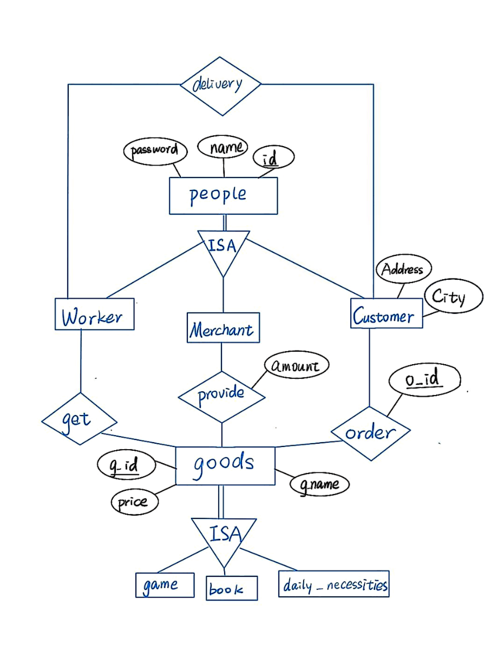**Merchandise page:** Use PHP to output all goods, which can show all their own goods by calling GOODS table, MERCHANTS table and PROVIDE table.

**ER diagram:**

Entity set: People, Worker, Merchant, Customer, Goods.

Relationship set: Order, Get, Provide, delivery.

Worker, Merchant and Customer are inherited from people.

Goods and Merchant have relationship set(Provide) which is used to link this two table.

Order links Customer and Goods, and Order can be used to find out this customer’s history order.

Get is relationship set of Goods and Worker.

Workers Get goods and Delivery the goods to Customer.

**Functional dependencies and schemas:**

R={cid, cname, c_password, c_city, c_address, gid, gname, price, mid, mname, m_password, m_city, m_address, oid}

F={cid->cname, c_password, c_city, c_address,

gid-> gname, price

mid-> mname, m_password, m_city, m_address , gid}

“oid” is independence, because this attribute is multiple values, which means it can not depend on others.

R1={cid, cname, c_password, c_city, c_address, gid, gname, price, mid, mname, m_password, m_city, m_address}

R2={oid}

R11={cid, cname, c_password, c_city, c_address}

R12={gid, gname, price }

R13={mid, mname, m_password, m_city, m_address}

R14={cid,mid}

Result = {R2,R11,R12,R13,R14}

**Primary key:**

cid, mid, gid, oid

**Workload of each Team member:**

* 22%(朱勋明)Login

(朱勋明)Register

* 22% (熊一鸣)Shop Page（Show goods briefly）

(熊一鸣)Order Page

* 22% (何贝儿)Information Page one for Customer

(何贝儿)Information Page one for Merchant

* 22%(黄媛骞)Find History Order

(黄媛骞)Find What Goods The Merchants Have

* 12%(胡行)Detail Page for Customer,

(胡行)Detail Page for Merchants